**ACKNOWLEDGEMENT**

We want to express our deepest gratitude and regards towards all the teachers who have been very supportive and encouraging. We would specially thank to Principal Dr. Janardan Pawar & Vice Principal Dr. Shivendu Bhusan, for their constant support.

We wish to express our profound and sincere gratitude to Mrs. Kavita Dhakad Ma’am& Mr. Ashish Dhoke Sir for their valuable guidance. Their keep interest in this project and constant and timely encouragement with affectionate attitude have inspired us a lot to learn & finish our work successfully. Lastly,We would like thanks to all my teachers and friends who have contributed in bringing out this project in present format.

**INDEX**

1. INTRODUCTION

* Problem Statement
* Purpose/ Objective & Goals
* Project Scope & Limitations

1. SYSTEM ANALYSIS

* Existing Systems
* Scope & Limitations of Existing System
* Project Perspective & Features
* Stakeholders
* Requirement Analysis- Functional requirements, Performance requirements, Security requirements, etc.

1. SYSTEM DESIGN

* System Model: Using OOSE
* Data Model – Using ERD
* Data Dictionary

1. IMPLEMENTATION DETAILS

* Software Specifications
* Hardware specifications

1. TESTING

* Test Plan
* Data Validation Screens

1. INPUT & OUTPUT SCREENS
2. REPORTS
3. CONCLUSION & RECOMMENDATIONS
4. FUTURE SCOPE
5. BIBLIOGRAPHY & REFERENCES

**INTRODUCTION**

* PROBLEM STATEMENT:

Customer Relationship Management System is a web application developed for the purpose of handling data of customers by store or business managers and their customers. It facilitates to access the information of a particular customer in an institute, which is created, read, updated, deleted, and stored by a manager for a particular customer behavior.

The managers can also create appointments with their customers and view and download reports. The customers can provide their feedback and create appointments with the managers. By following just few simple steps, the system can be used to store customer data thus minimizing the manual labor, the scope of human error, and also the time consumed for the same. Thus, this system will automate the process of customer data handling.

The aim is to develop a web application with help of Spring, Hibernate, HTML/CSS and more technologies. The project is about creating a backend web application. The Customer Relationship Manager will keep track of all the customers. Adding new customers, editing their information, and deleting them when needed.

* PURPOSE / OBJECTIVE & GOALS:

The motivation of this project is to develop a web-based application which can assist the end users to create, read, update, delete and store information about their customers and create appointments and view and download appointment reports as per their requirements.

The customers can provide their feedback and create appointments with the managers. This system will considerably reduce the time consumed, the manual labor, the human error, and the hassle to store all the bulky records and the difficulty to access them.

It will provide an efficient platform for the end users, by enabling most of the tasks to be conducted and completed in a simple, untroubled way.

* PROJECT SCOPE & LIMITATIONS:

Customer Relationship Manager web application is widely used by managers to store, retrieve, and modify their customers' information. This project is the implementation of a backend web application where we can create, read, update, and delete (CRUD) customer information. This exciting CRUD application will be built using Spring MVC, Hibernate (ORM framework), and MySQL (for managing RDBMS).

Recording data of customers digitally over the internet without the need of manually creating, updating, deleting, and preserving the records in bulk is the basis of Customer Relationship Manager. The system is user friendly and can be used on various platforms as it is Web application based.

CRM data models should be designed according to business needs and rules. Therefore, there is a lack of standardization between CRM data models.

Each business has its security model with different roles such as manager, agent/representative, etc., in addition to custom privileges for each role such as access permission for specific functions or reports.

**SYSTEM ANALYSIS**

* EXISTING SYSTEM:

In current scenario, there are numerous websites, applications and systems used for managing customers’ data. Other option people use is manual way, like keeping books and registers filled with customer data.

Usually these website, application and system services have various features according to the need of the business but are usually paid. The manual provides no features and requires manual labor.

* SCOPE & LIMIATIONS OF EXISTING SYSTEM:

Currently there are numerous websites and applications for management of customer data, but they are time consuming and inefficient in terms of user convenience. Recording data of customers digitally over the internet without the need of manually creating, updating, deleting, and preserving the records in bulk is the basis of Customer Relationship Manager. The system is user friendly and can be used on various platforms as it is Web application based.

CRM data models should be designed according to business needs and rules. Therefore, there is a lack of standardization between CRM data models. Each business has its security model with different roles such as manager, agent/representative, etc., in addition to custom privileges for each role such as access permission for specific functions or reports.

Many systems do not follow standardized practices for data management, and even lack in providing required features and services. This leads to inconvenience for the user and makes the tasks difficult. Also, the present system can be expensive and can also contain hidden costs.

* PROJECT PERSPECTIVE & FEATURES:

1. To make data management easy, hassle-free and no cost for the users so that small and growing business can also use this system.
2. To provide features according to the needs and requirements of the users and their businesses.
3. To reduce time, energy and manual labor required for customer data management.
4. No need to use any third-party system or services, all the processes can be controlled by the user as necessary.
5. The system is user friendly no prior understanding of the system is required to use the CRM.

* STAKEHOLDERS:

1. Admin
2. Store/ Business Managers
3. Customers

* REQUIREMENT ANALYSIS:

1. Functional Requirements:

* Audit tracking [inspection of a user’s accounts]: Only valid Users will be allowed and monitored.
* Administrative functions [Active, Staff, Superuser; categories]: Users can be of multiple categories and can hold multiple permissions

1. Performance Requirements:

* Internet
* Quick Response Time
* Correct Customer Data Management

1. Security Requirements:

* Authentication and password management
* Authorization and role management
* Audit logging and analysis

Network and data security

* Cross site scripting (XSS) protection**:** XSS attacks allow a user to inject client-side scripts into the browsers of other users.
* Cross site request forgery (CSRF) protection: CSRF attacks allow a malicious user to execute actions using the credentials of another user without that user’s knowledge or consent.
* SQL injection protection: SQL injection is a type of attack where a malicious user can execute arbitrary SQL code on a database
* Referrer policy: Browsers use the Referrer header to send information to a site about how users got there.

**SYSTEM DESIGN**

* SYSTEM MODEL : USING OOSE

1.CLASS DIAGRAM:

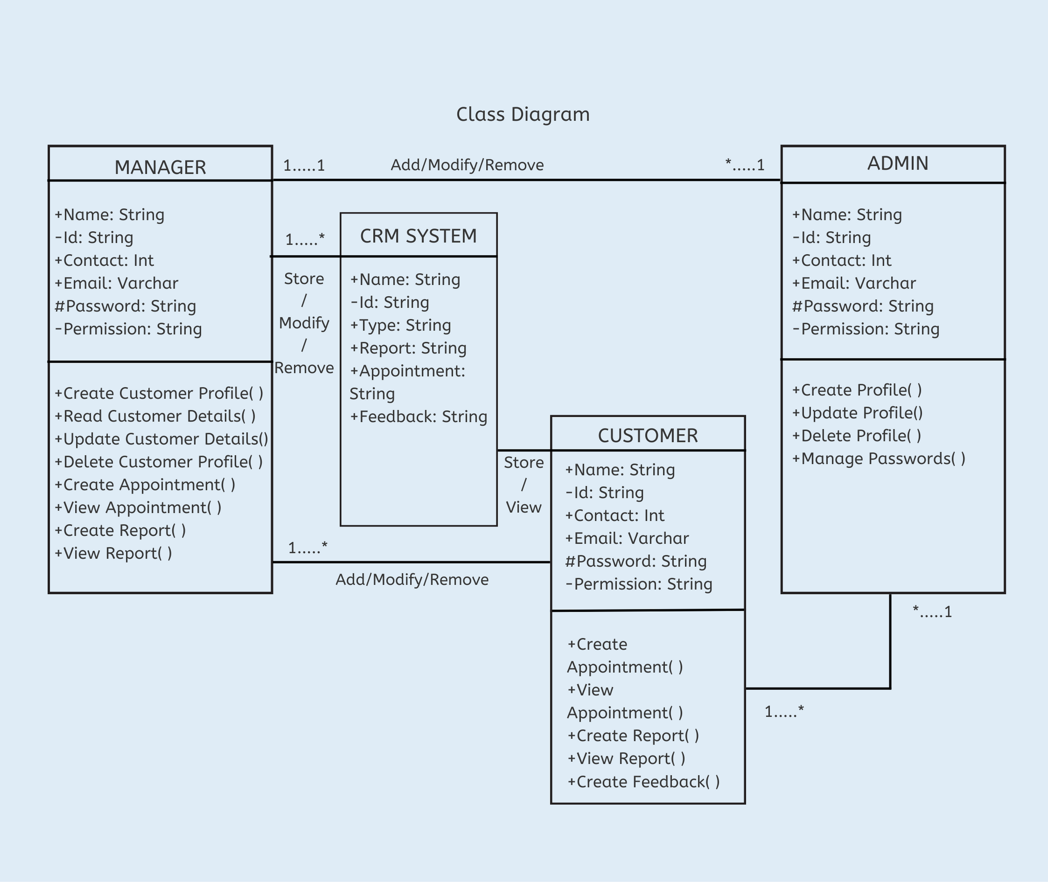

2. USE CASE DIAGRAM:

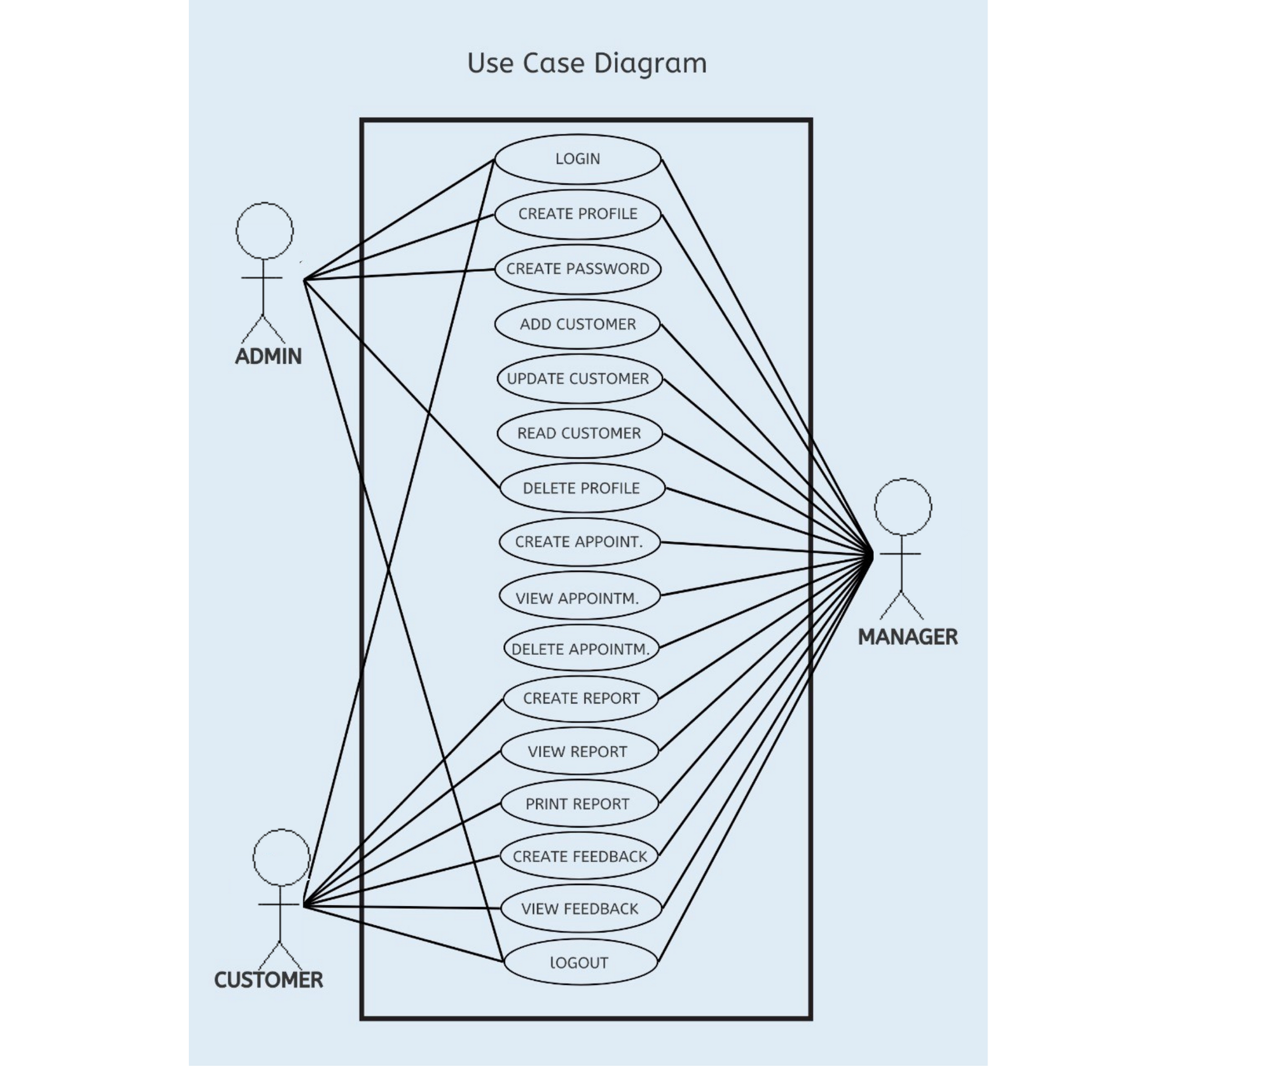

3.COMPONENT DIAGRAM:

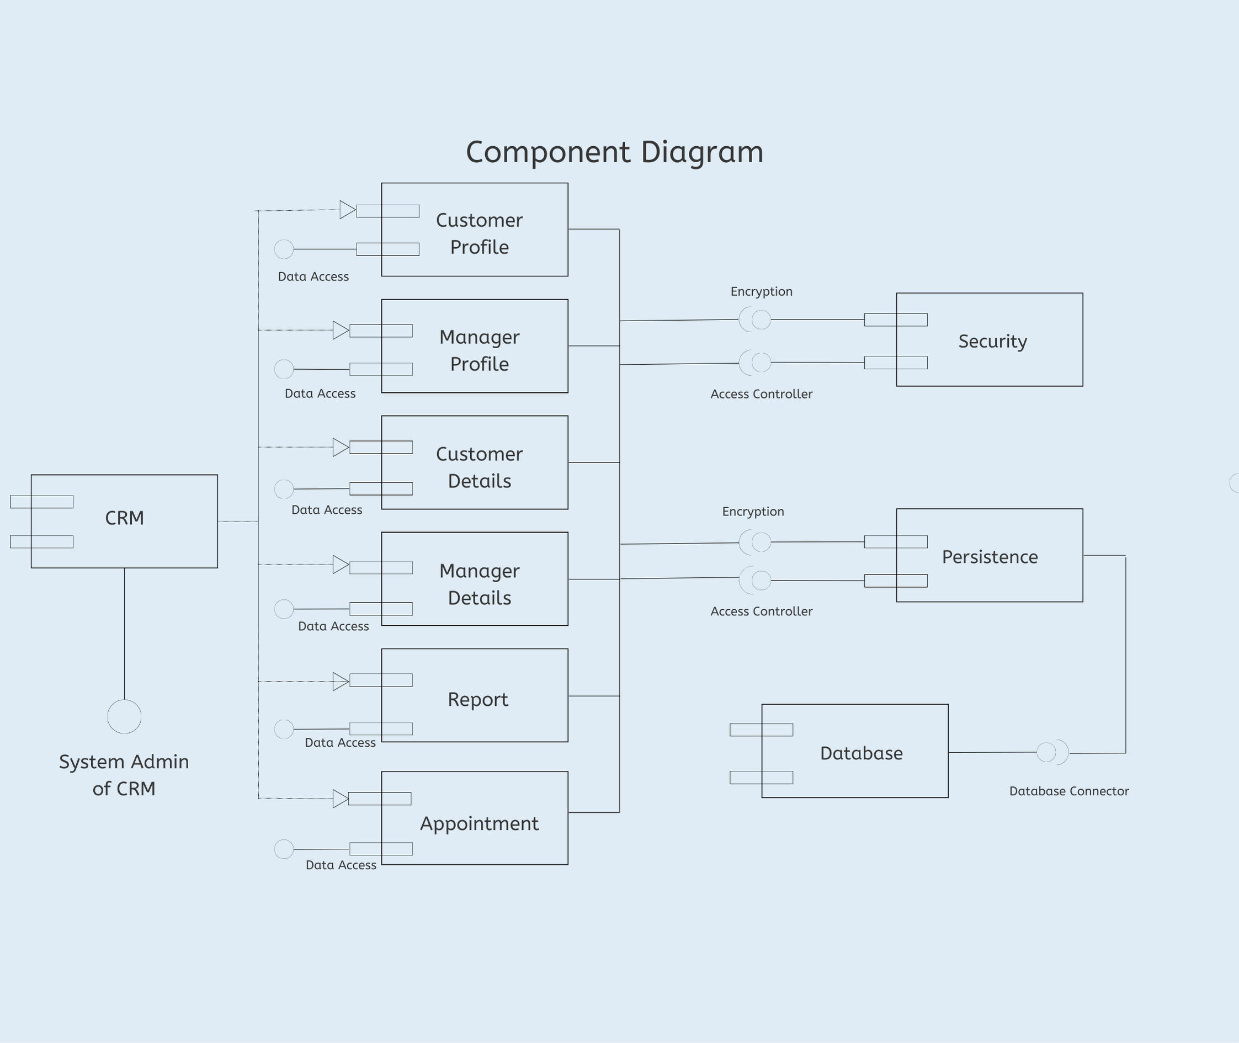

4.SEQUENCE DIAGRAM:

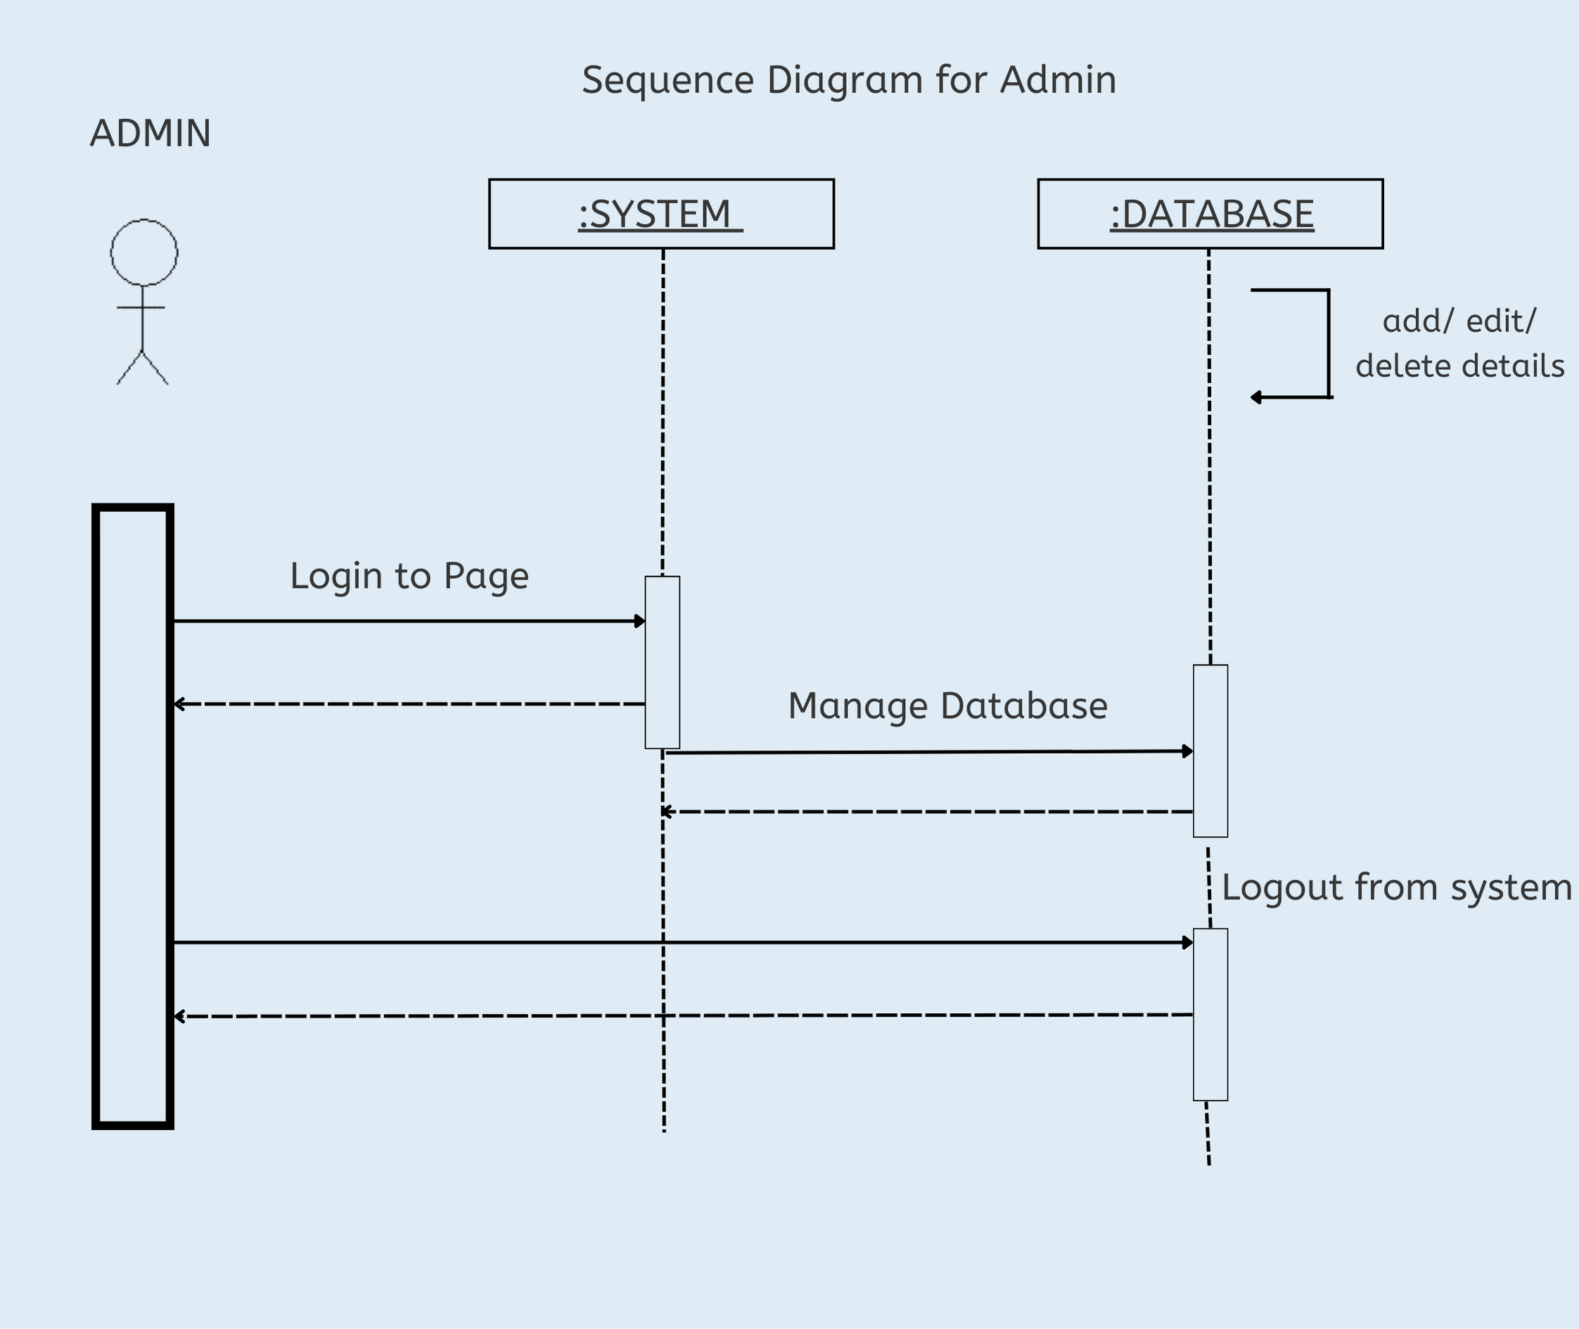

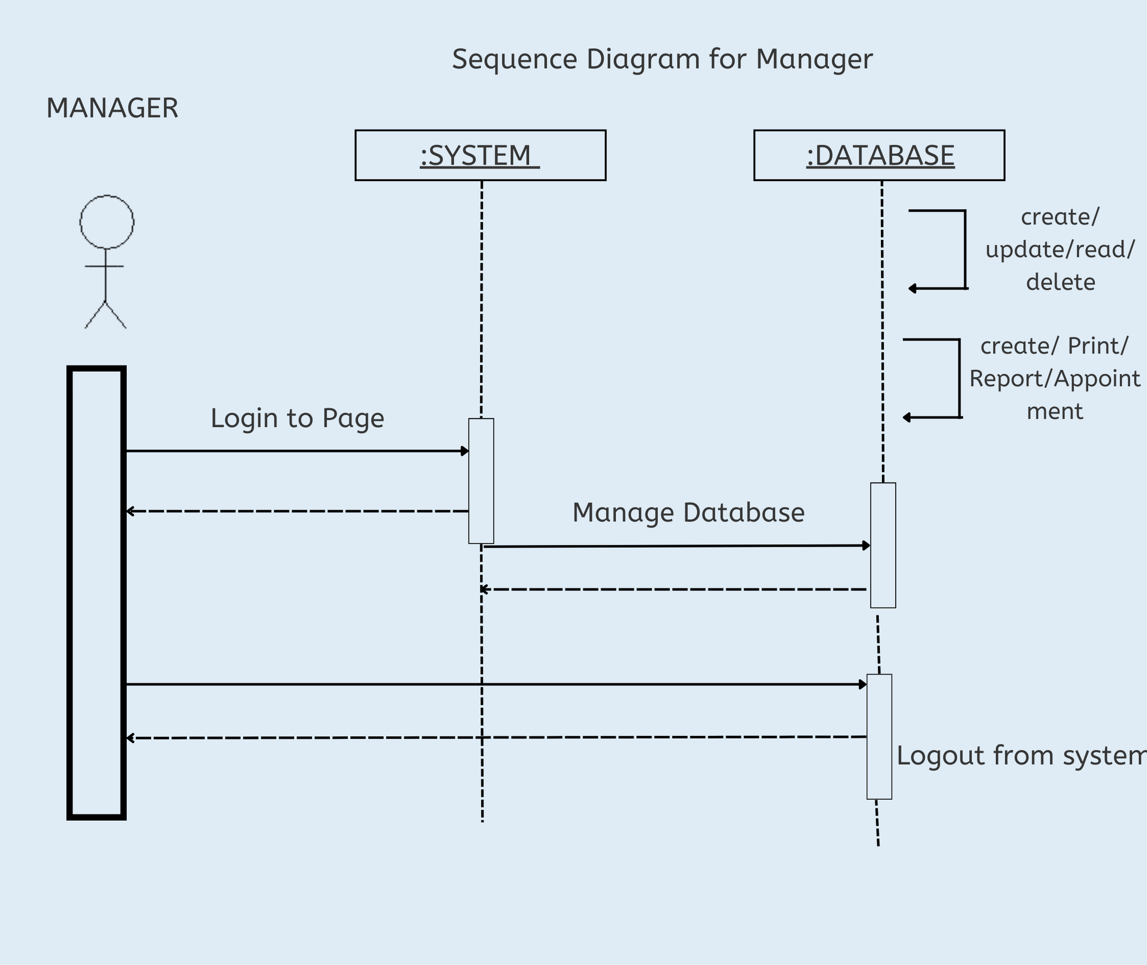

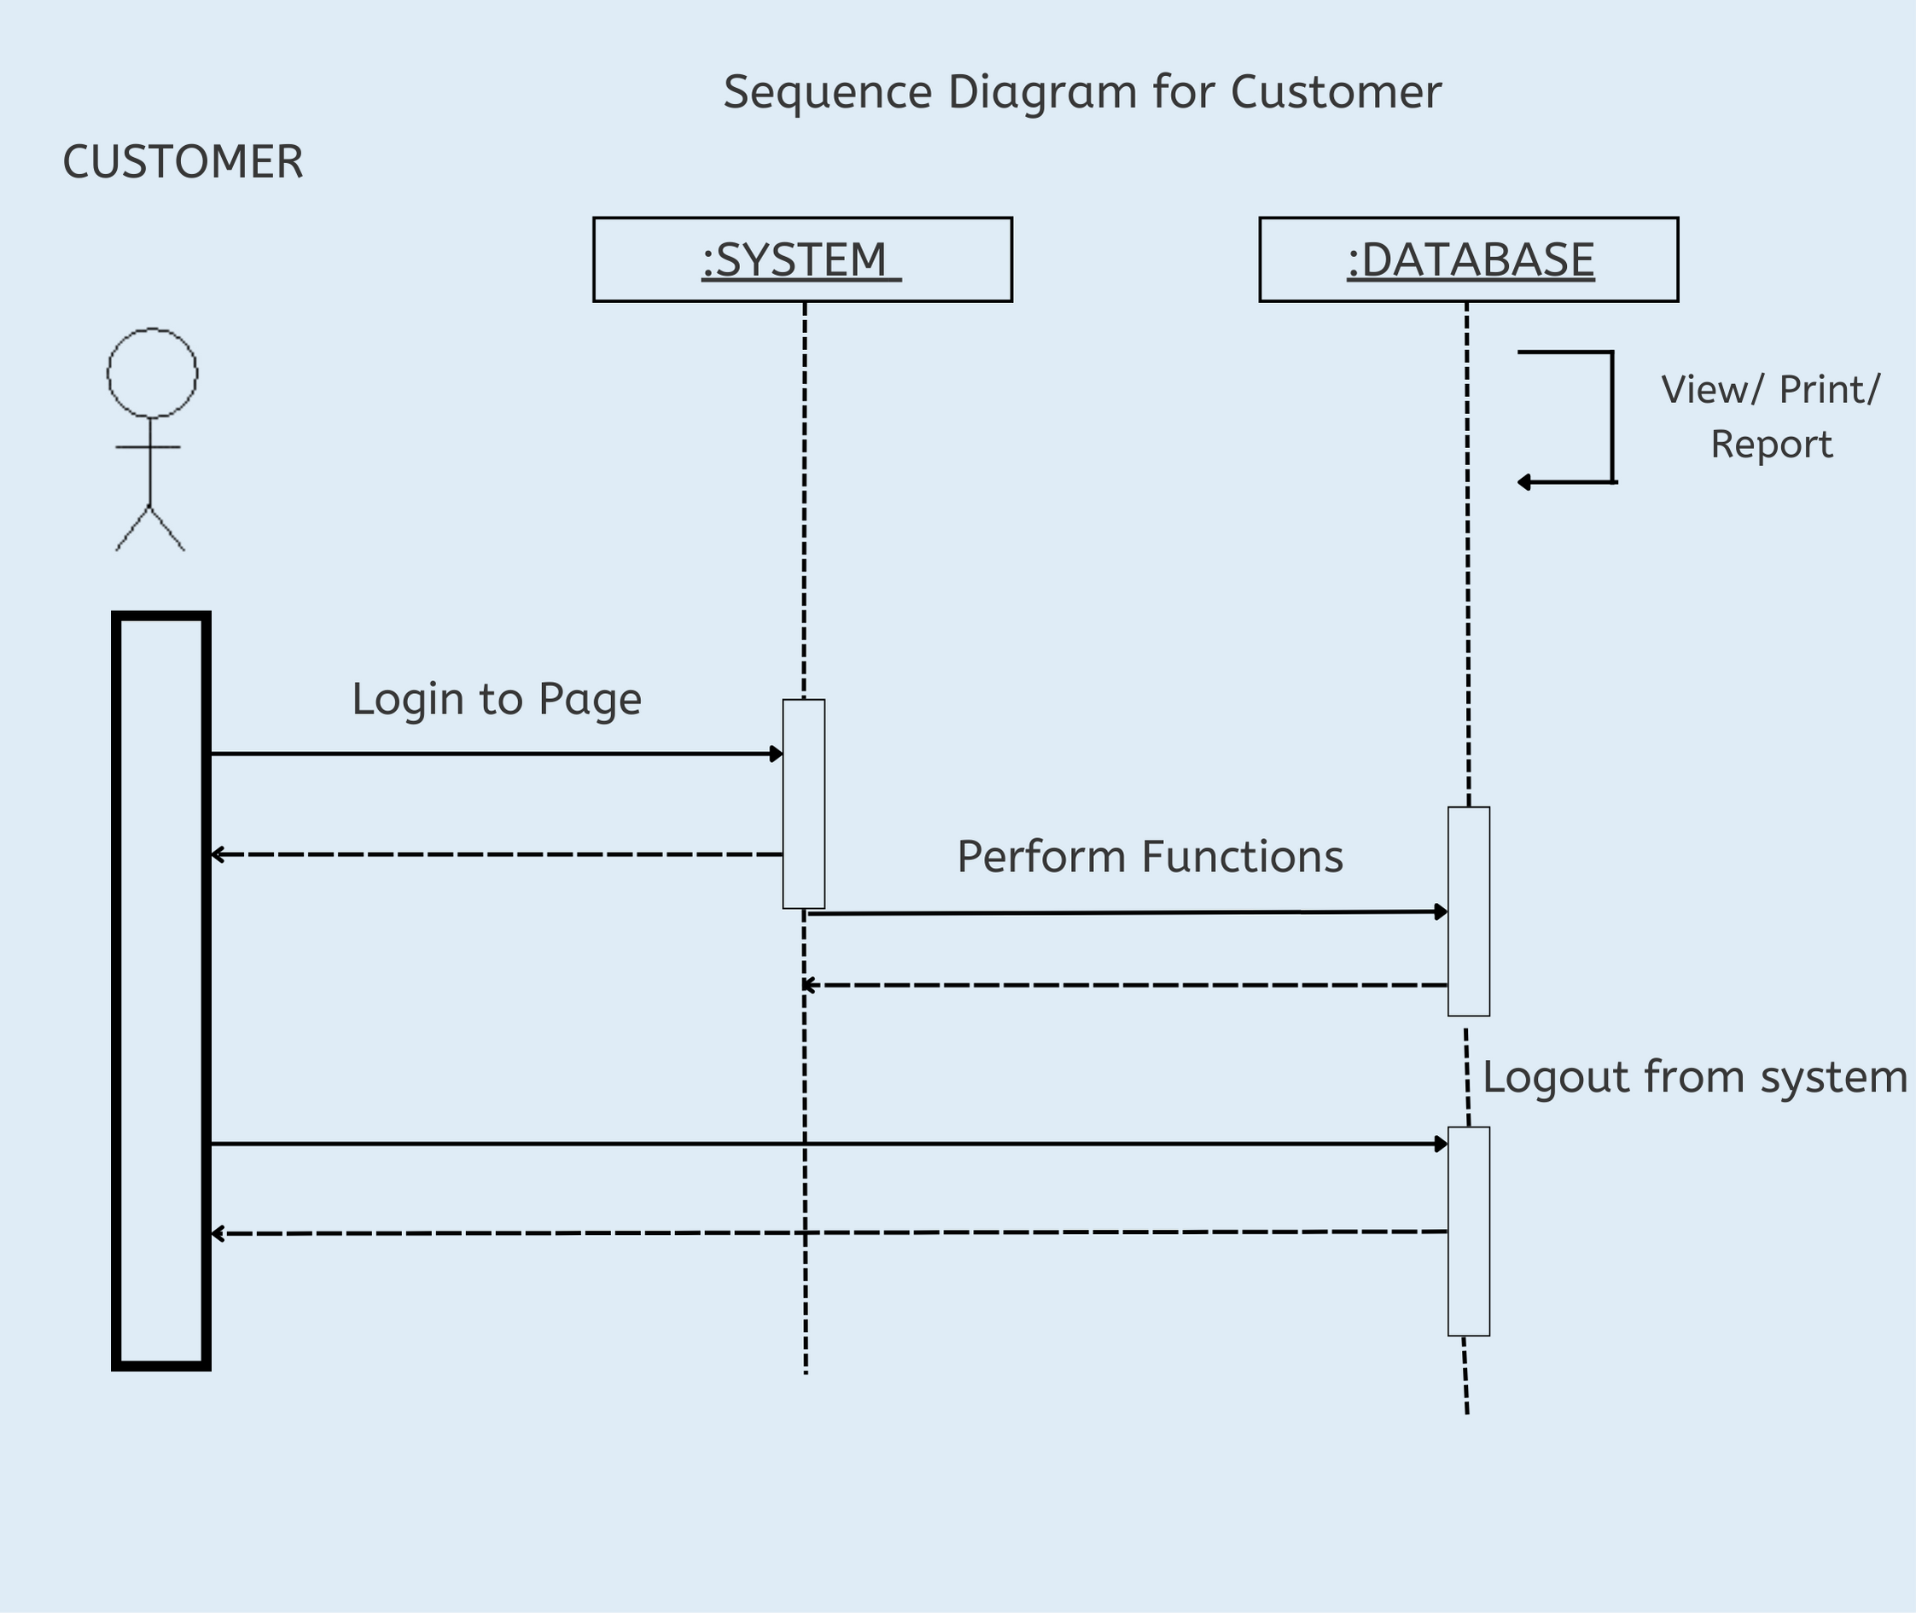

5.ACTIVITY DIAGRAM:

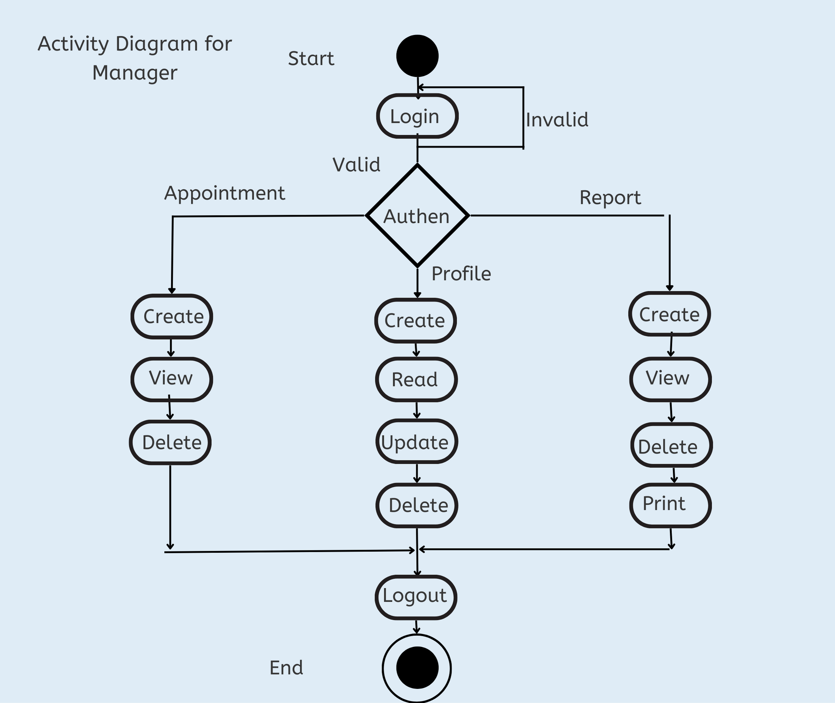

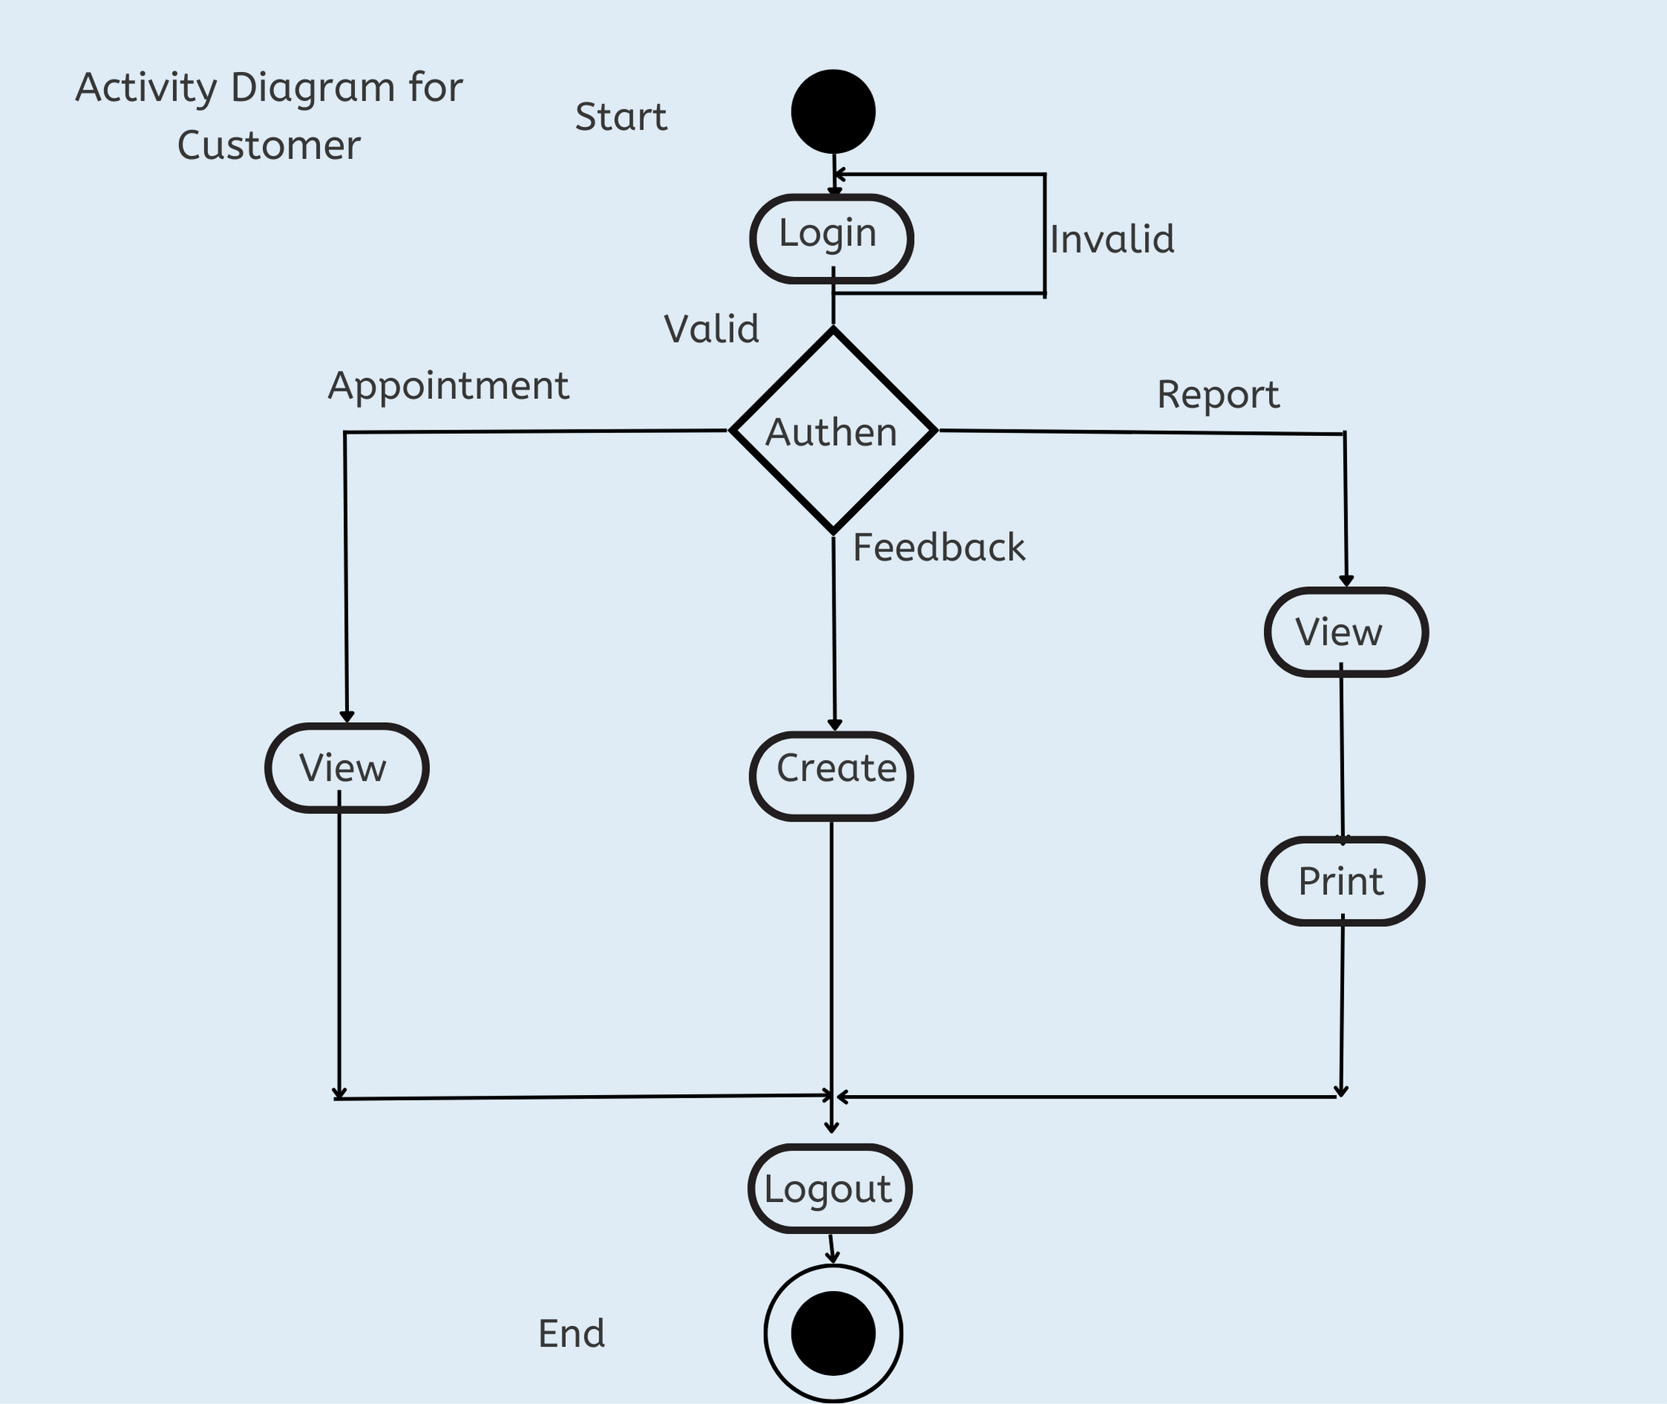

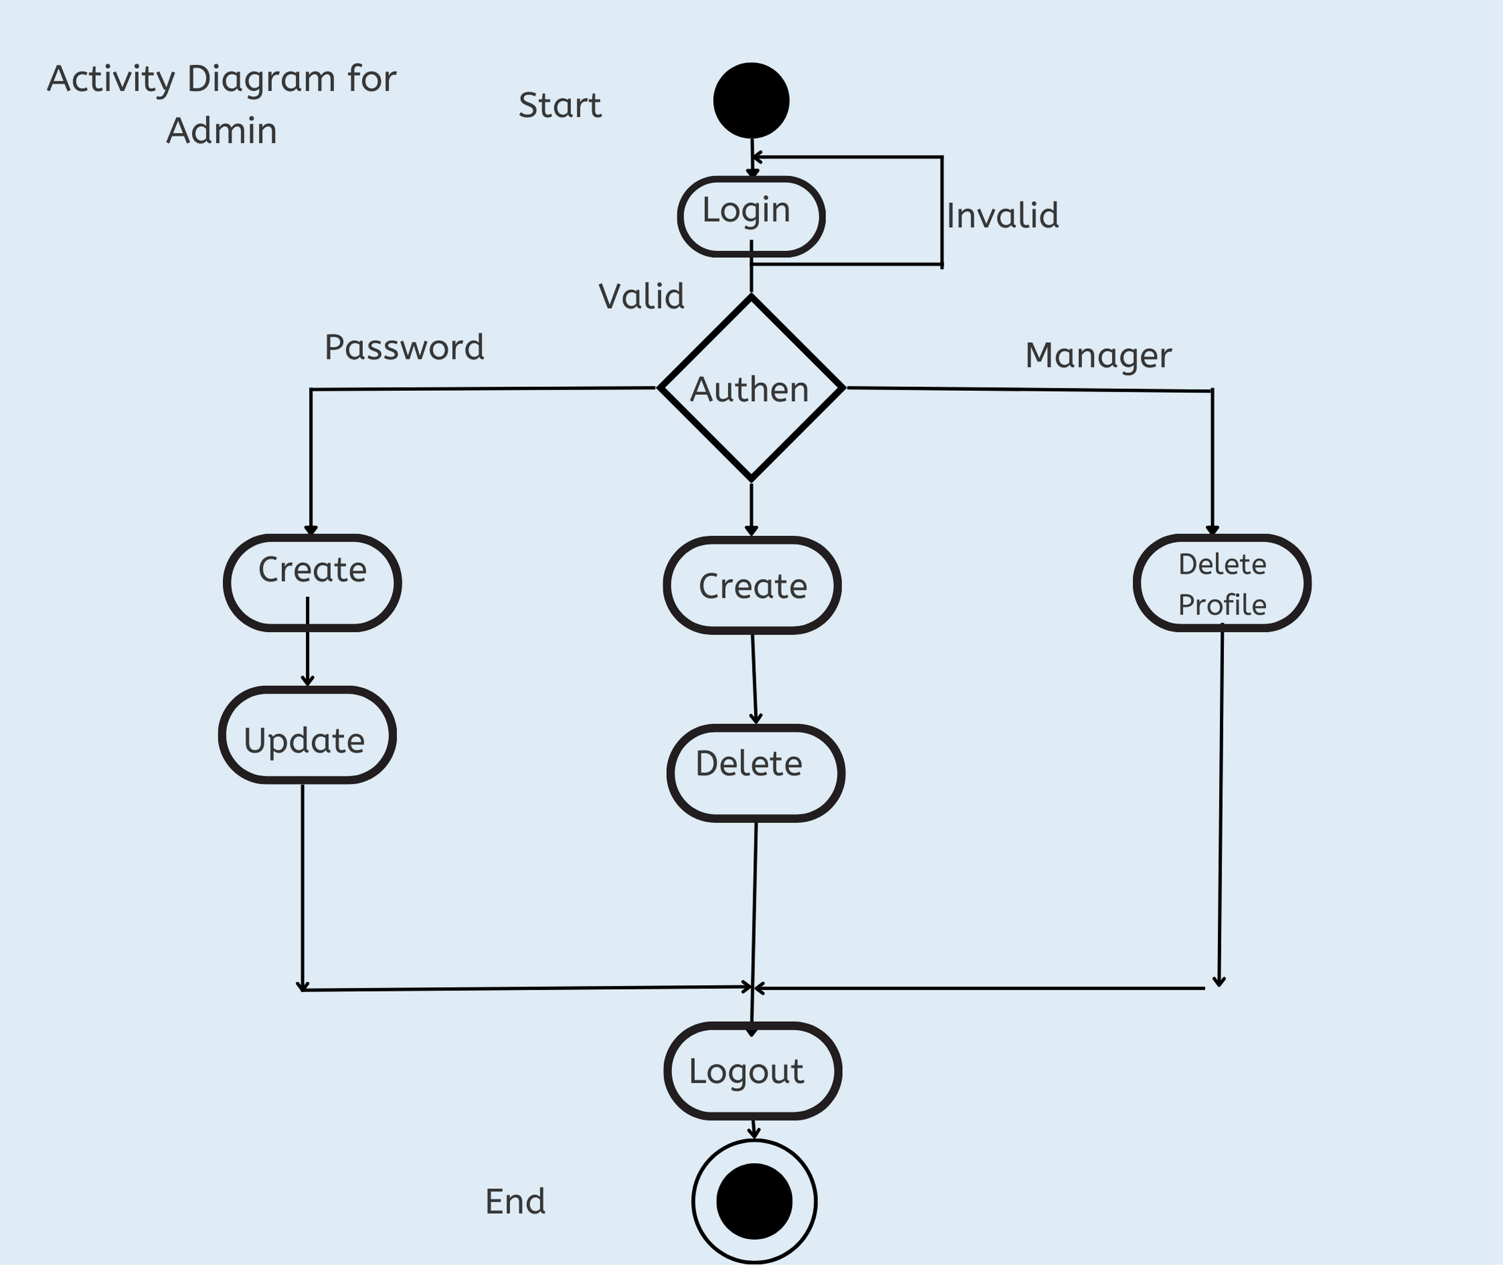

6.DEPLOYMENT DIAGRAM:

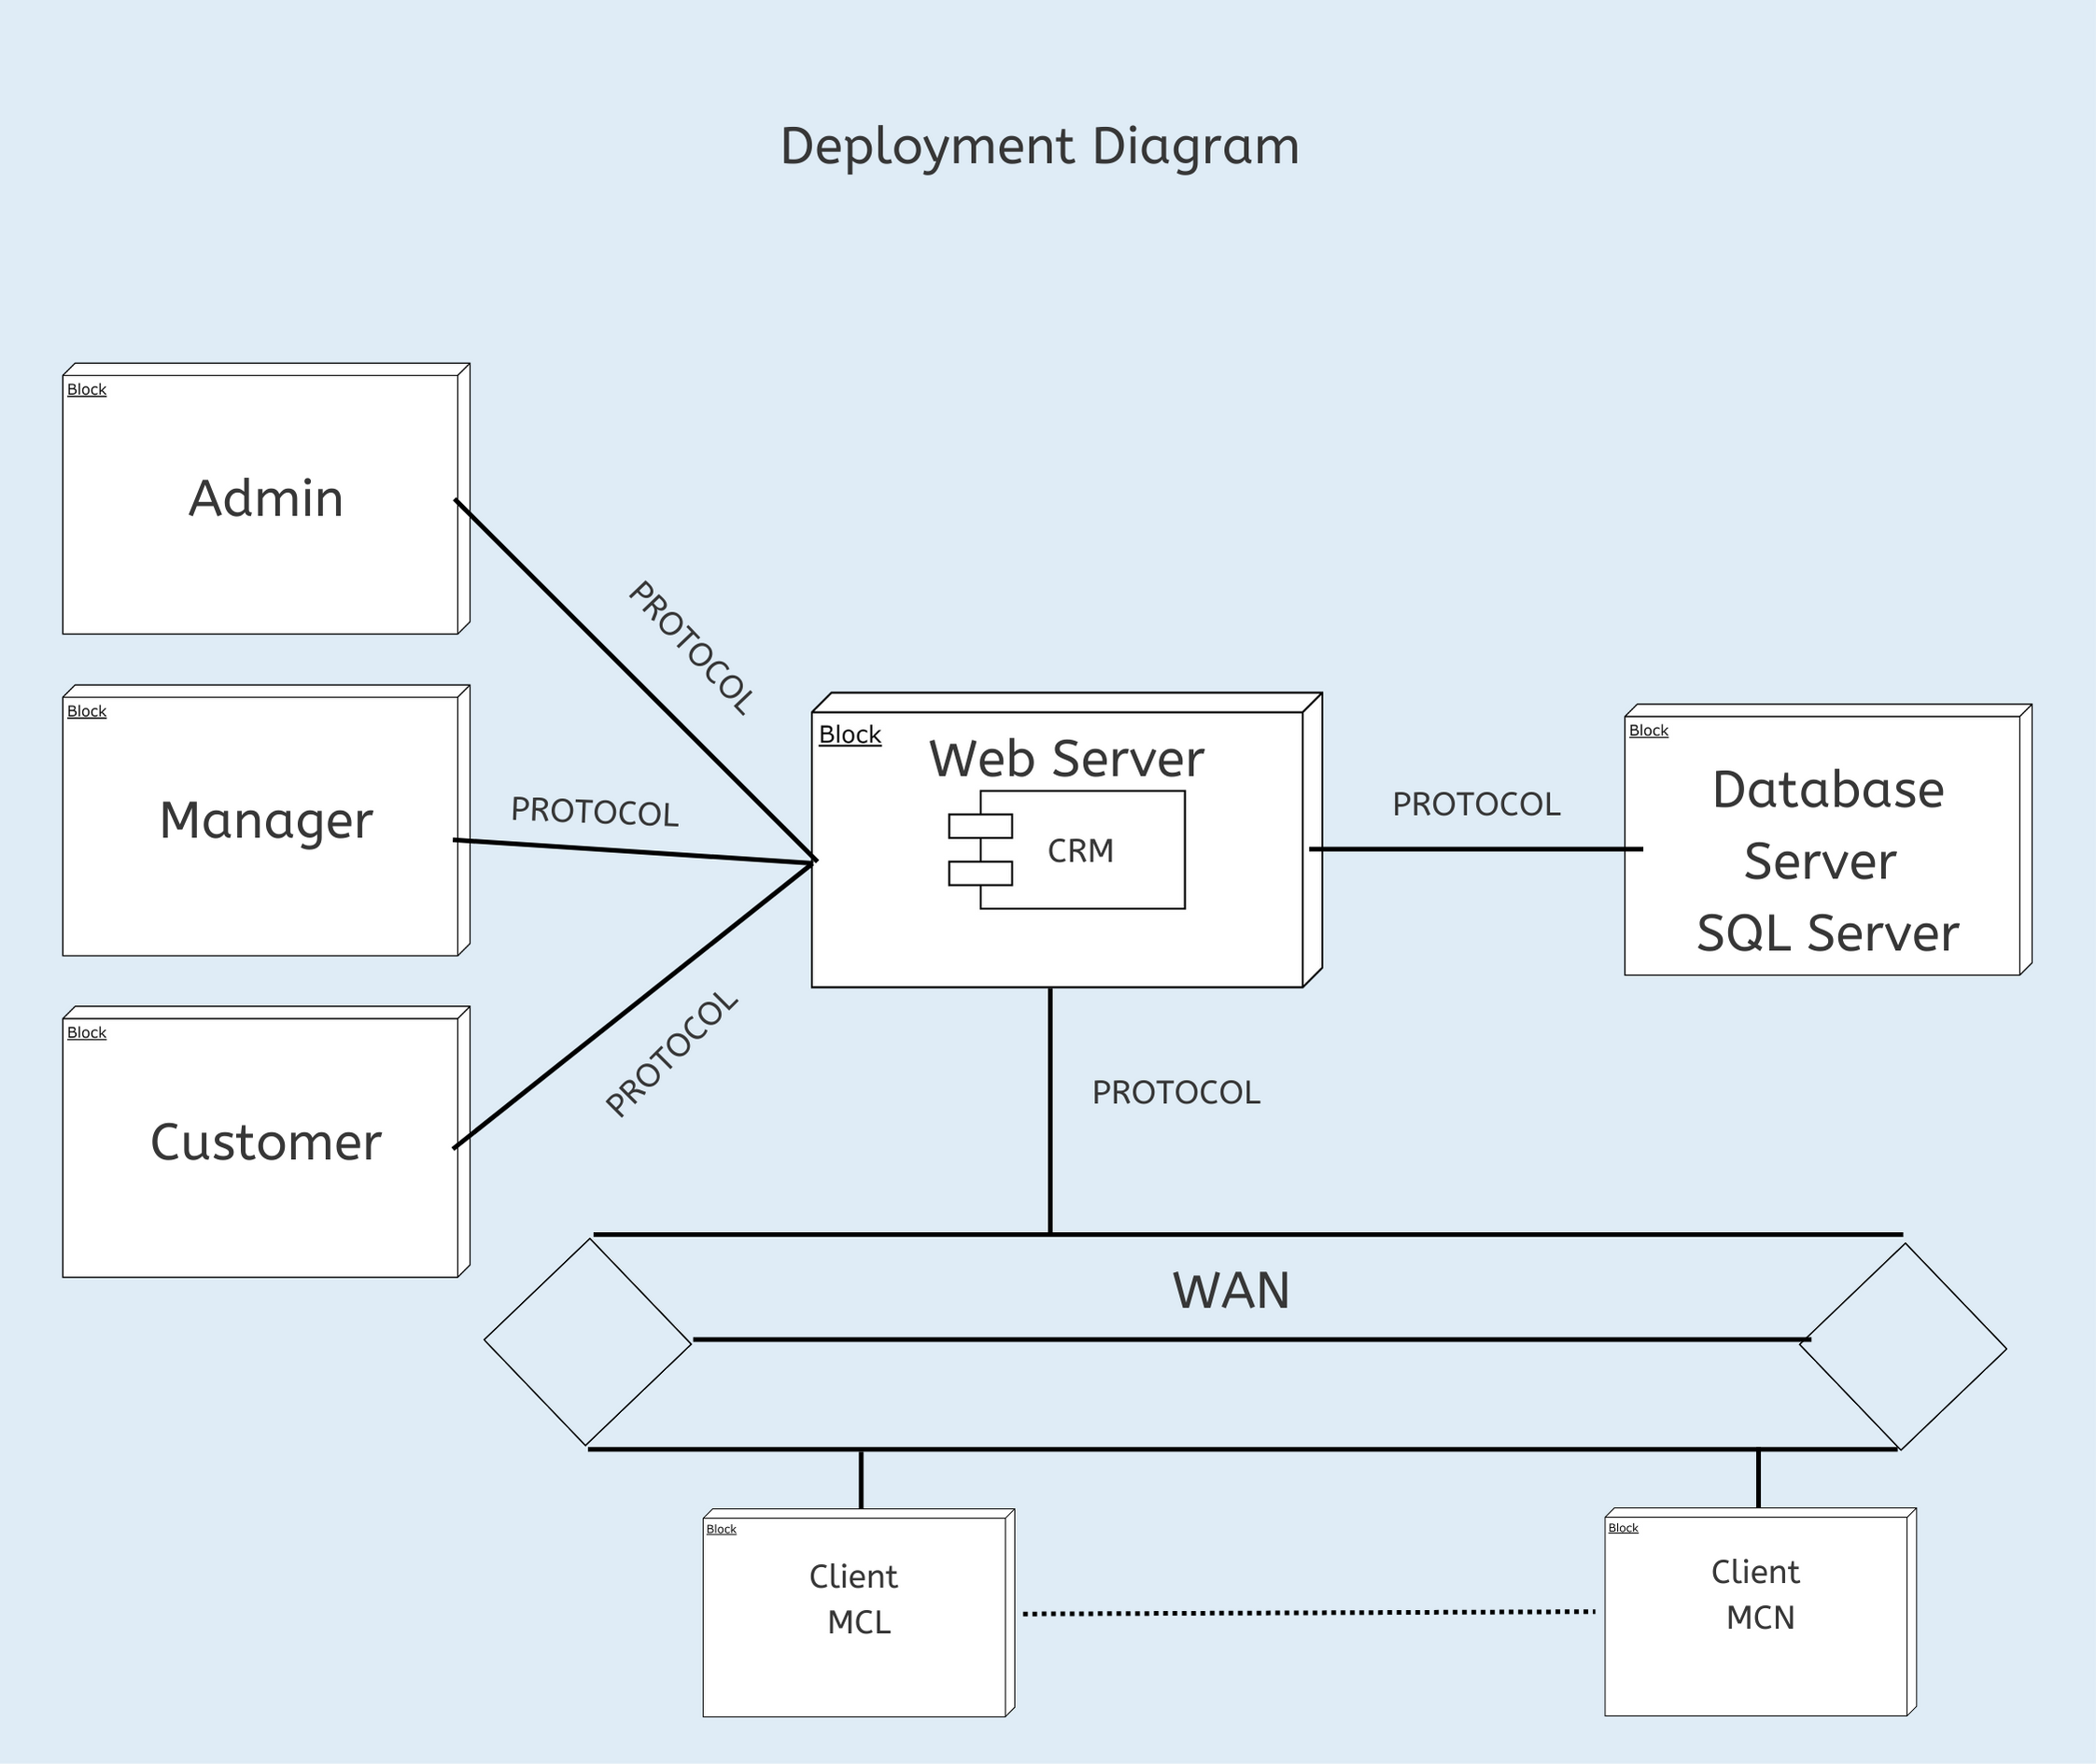

* COLLABORATION DIAGRAM:

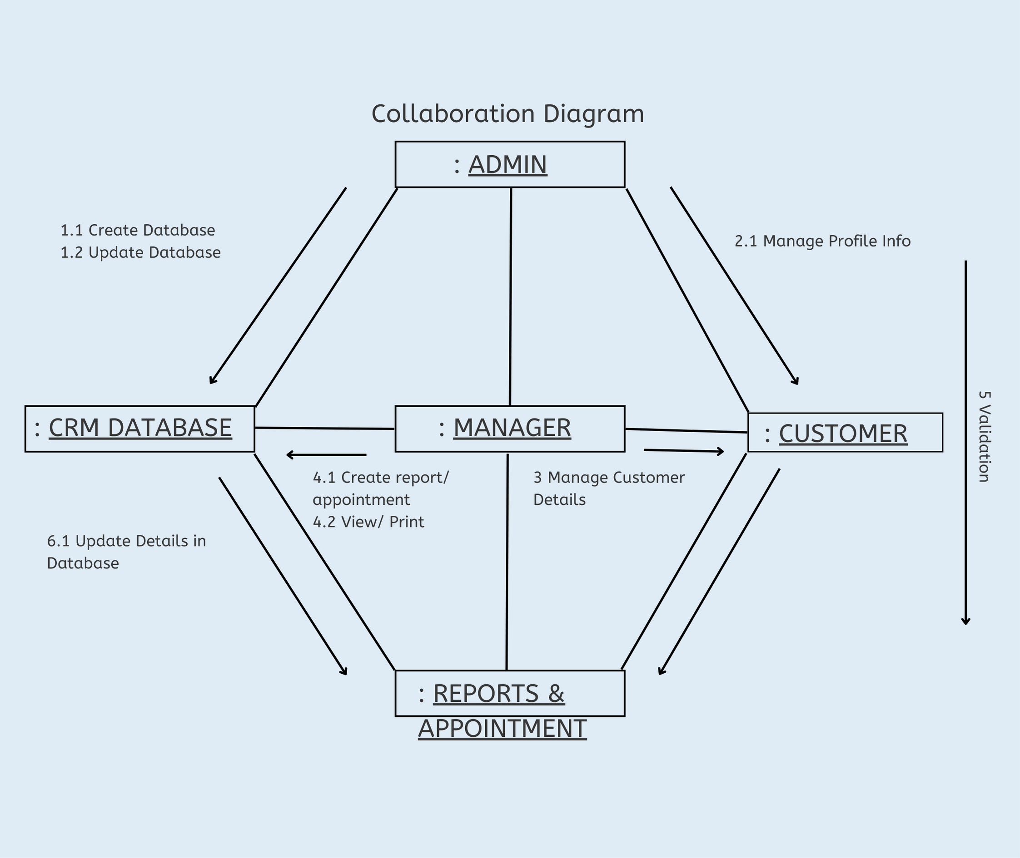

* DATA MODEL USING ERD:

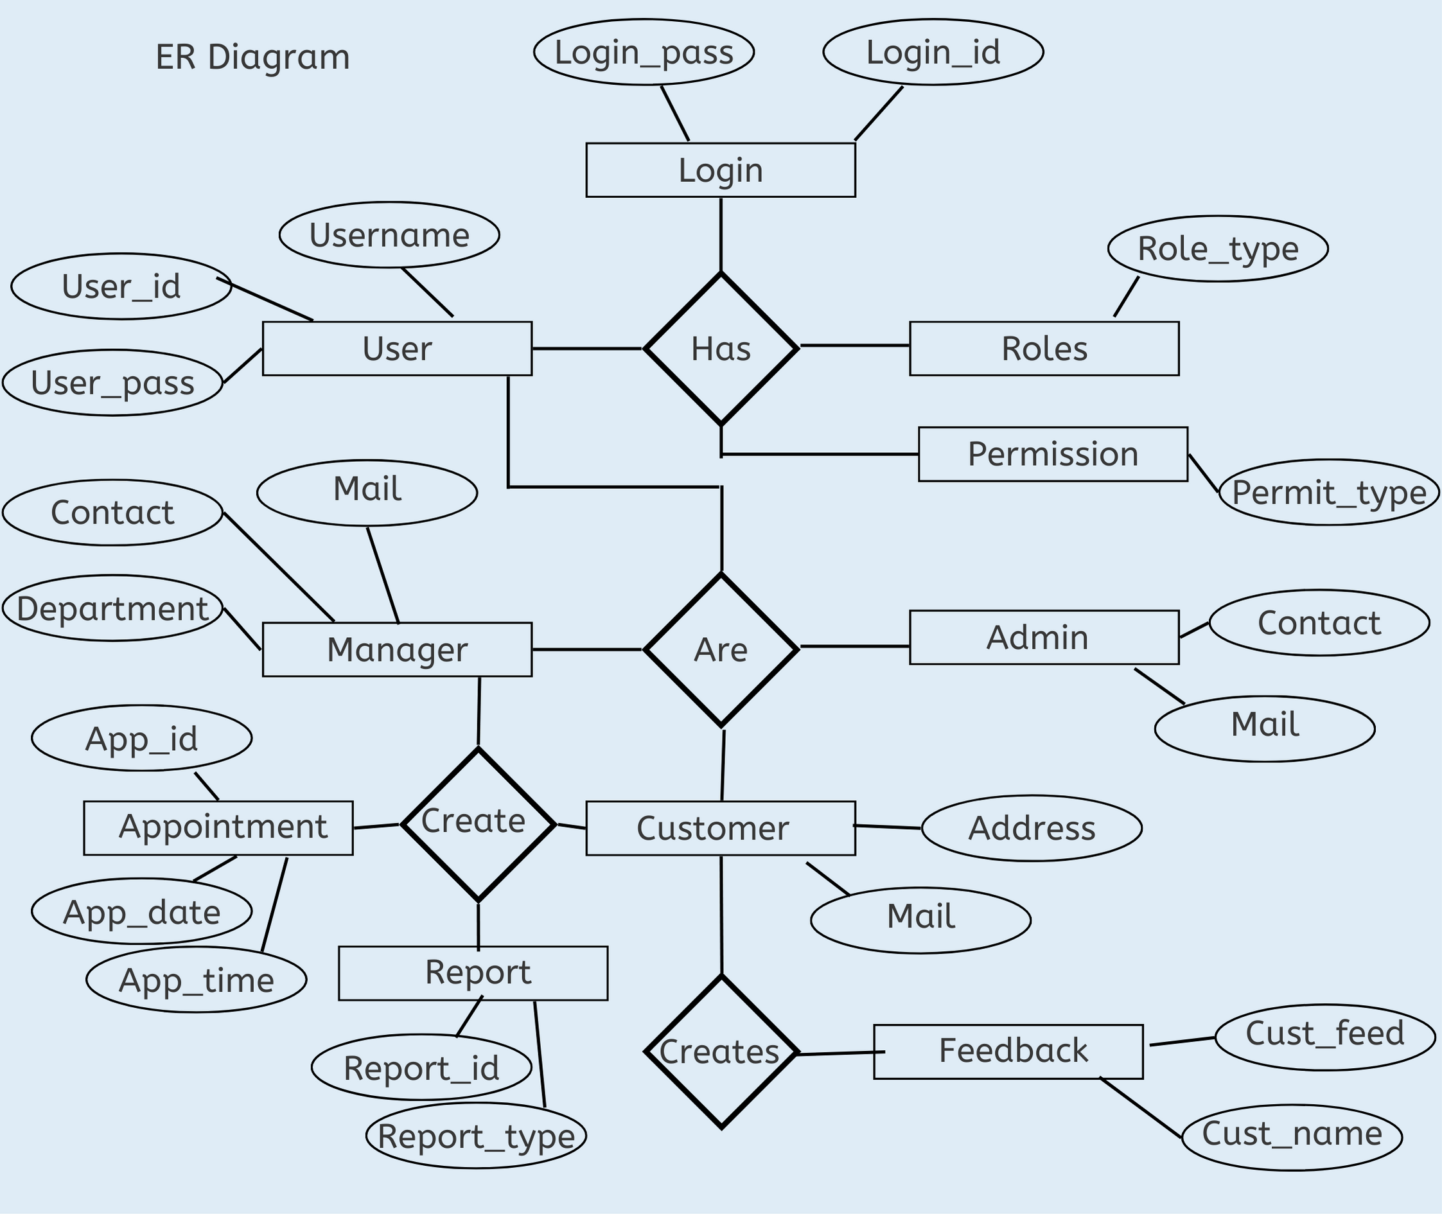

* DATA DICTIONARY:

|  |  |  |  |  |  |
| --- | --- | --- | --- | --- | --- |
| Users | | | | | |
| **Attribute** | **Key** | **Types** | **Size(bytes)** | **Required** | **Examples** |
| Id | Primary | Integer | 8 | Y | 1,2,3.. |
| username | - | varchar | 50 | Y | anyname |
| password | - | varchar | 50 | Y | password |

|  |  |  |  |  |  |
| --- | --- | --- | --- | --- | --- |
| Customer | | | | | |
| **Attribute** | **Key** | **Types** | **Size(bytes)** | **Required** | **Examples** |
| Id | Primary | Integer | 8 | Y | 1,2,3.. |
| custname | - | varchar | 50 | Y | anyname |
| custaddone | - | varchar | 50 | Y | Address1 |
| custaddtwo | - | varchar | 50 | N | Address2 |
| custcity | - | varchar | 20 | Y | Cityn ame |
| custstate | - | varchar | 20 | Y | State name |
| custmobile | - | varchar | 15 | y | Mobile no. |
| custemail | - | varchar | 50 | Y | mail@email.com |

|  |  |  |  |  |  |
| --- | --- | --- | --- | --- | --- |
| Appointment | | | | | |
| **Attribute** | **Key** | **Types** | **Size(bytes)** | **Required** | **Examples** |
| Id | Primary | Integer | 8 | Y | 1,2,3.. |
| apptitle | - | varchar | 50 | Y | Title |
| appsubj | - | varchar | 50 | Y | Subject |
| appdesc | - | varchar | 50 | N | Description |
| appname | - | varchar | 50 | Y | Name of appt |
| apploc | - | varchar | 20 | Y | Location,platform |
| appurl | - | varchar | 50 | y | URL/Link of meet |
| appdate | - | date |  | Y | DATE |

|  |  |  |  |  |  |
| --- | --- | --- | --- | --- | --- |
| Feedback | | | | | |
| **Attribute** | **Key** | **Types** | **Size(bytes)** | **Required** | **Examples** |
| Id | Primary | Integer | 8 | Y | 1,2,3.. |
| custfname | - | varchar | 50 | Y | anyname |
| custfemail | - | varchar | 50 | Y | ml@email.com |

|  |  |  |  |  |  |
| --- | --- | --- | --- | --- | --- |
| custfeedback | - | varchar | 500 | Y | Feedback  Good/bad |
| custfdate | - | date | - | y | 22/01/2020 |

IMPLEMENTATION DETAILS

SOFTWARE SPECIFICATIONS:

PROGRAMMING LANGUAGES -

* Java
* HTML / CSS
* MySQL

DEVELOPMENT TOOLS –

* Linux Operating System
* Eclipse IDE Enterprise Java Version 4.22(2021)
* Apache Tomcat 10.0.2
* Java Version 8
* MySQL 8.0
* MySQL Workbench 8.0
* MySQL Connector Java 8.0.29

HARDWARE SPECIFICATIONS:

* Processor : Intel Core Duo 2.0 GHz or more.
* RAM : 1 GB or more.
* Hard disk : 80 GB or more.
* Monitor : LCD monitor with 1080p resolution.
* Keyboard : Normal or multimedia.

Mouse : Compatible

TESTING

* TEST PLAN:

**Test Plan Identifier**

Full Identifier Form: Customer Relationship Management System Test Plan - 08/22 Version1.0

Short Identifier Form: CRMS Test Plan - 08/22 V1

Subsequent test plans for this project will follow the same naming convention:

Customer Relationship Management System

**Introduction**

The Test Plan is based on the standard guidelines from IEEE 829-1998. The Test Plan for Customer Relationship Management System is described in this document. All the functionalities listed or specified in the Software Requirements Specification (SRS) are tested in accordance with this Test Plan. The overall scope, in this version, is to provide high level test plan which defines areas of emphasis for future expansion as the architecture and design evolve. It is expected that the Test Plan becomes more detailed as more details are known about the systems approach to the requirements.

The Test Plan is designed to prescribe the scope, approach, resources, and schedule of all testing activities. The plan must identify the items to be tested, the features to be tested, the types of testing to be performed, the personnel responsible for testing, the resources and schedule required to complete testing, and the risks associated with the plan.

**Objectives**

The Test Plan for the Customer Relationship Management System will support the following objectives:

Identify the features of the project that need to be tested.

Defining the activities required to prepare for and conduct system, acceptance usability, performance, integration and unit testing.

Define the pass/fail criteria for each item that would be tested.

Define the suspension criteria and resumption technique for the same.

Finally identify the deliverables of the testing process.

**Scope**

This document will describe the approach, resources, and schedule of the testing activities possible at this time. Any further elaboration will be completed as possible and will be presented in updated versions of this document. This document will also identify the particulars of testing (what to test, what not to test), the tasks that need to be performed, the method of testing, the persons responsible for testing, and the risks associated with this plan.

**Test Items**

This section of the Test Plan deals with the testing of all those items that constitutes CRMS. Specifically, all the items which are listed in the vision document and that make up the CRMS will be tested. Any upgrades to the existing versions of the test items will be done. Since we are considering the modern approach, wherein upon iterations we will be having the new requirements and design models that needs to be tested and reviewed along with the source code. In this way adequate testing is done throughout the product development. The following is the list to be tested:

Managing Login Process

**Features to be tested**

**Managing Login Process**

|  |  |  |  |
| --- | --- | --- | --- |
| **ID** | **Test Case** | **User Input** | **Pass Criteria** |
| Test 4.2.1 | User Login | User enters a wrong  Username | Display message  Login or Password is incorrect. |
| Test 4.2.2 | User Login | User enters a wrong  Password | Display message  Login or Password is incorrect. |
| Test 4.2.3 | User Login | User enters correct  Username and  password | User logs in successfully |

**Test Deliverables**

**Test Plan:** This is the document you are currently viewing.

Test Design Specification

Test Case Specifications: It will be created based on the test design specifications.

Test Procedure Specifications: It will define the methods used to perform testing, including all protocols and rules to adhere to.

Test Item Transmittal Reports: It will contain the current status and location of all the test items.

**Test Logs:** It will contain the log information for each test run. A Test Log will be maintained during testing and provided concluding testing. All tests will be recorded as either passed or failed. All failed test will contain a description, date, and time of the failure, along with a recommended solution. Along with the Test Log other deliverables are Test Plan and Test Cases.

Test Incident Reports: There will be one of these for each testing issue uncovered and it will detail how it was found and other related information.

**Test Summary Reports:** It summarizes all of the test incident reports and logs. This provides an overview of what the testing process uncovered.

**Risks and Contingencies**

Some of the risks for the testing include the risks of failing to find critical bugs and issues that are real show stoppers for the users. The contingency plans around this include adding extra layers of redundancy in data protection and in system service up time provided by the system. That way if one instance of the system fails the other should hopefully be able to recover.

**Test Completeness**

• Specifies the criteria that denote a successful completion of a test phase Run rate is mandatory to be 100% unless a clear reason is given.

• Pass rate is 80%, achieving the pass rate is mandatory

DATA VALIDATION SCREENS

* + - 1. Username with ‘@’ symbol required:

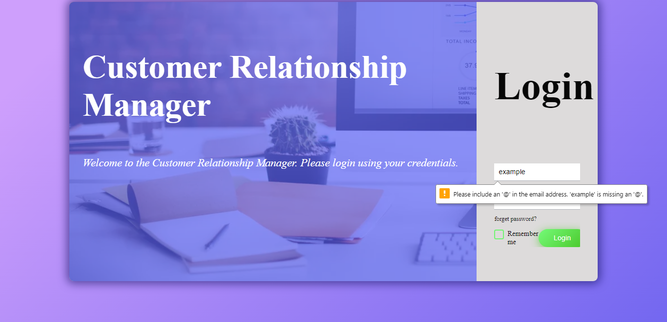

* + - 1. Password should be hidden:

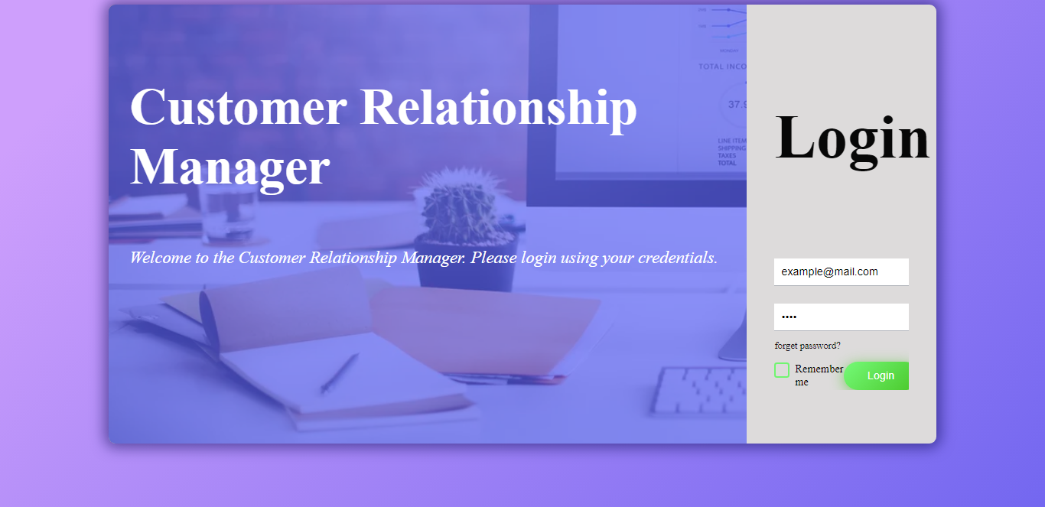

* + - 1. Required fields must be filled:

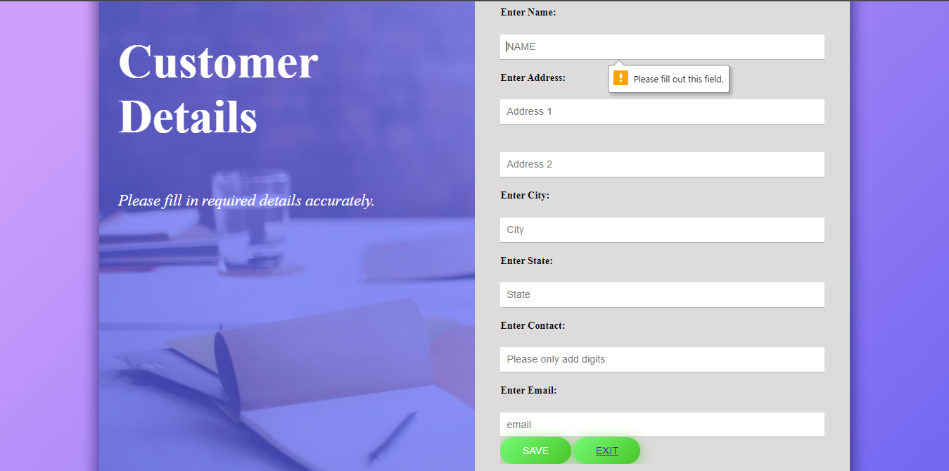

Contact Number should be filled in Digit format only:

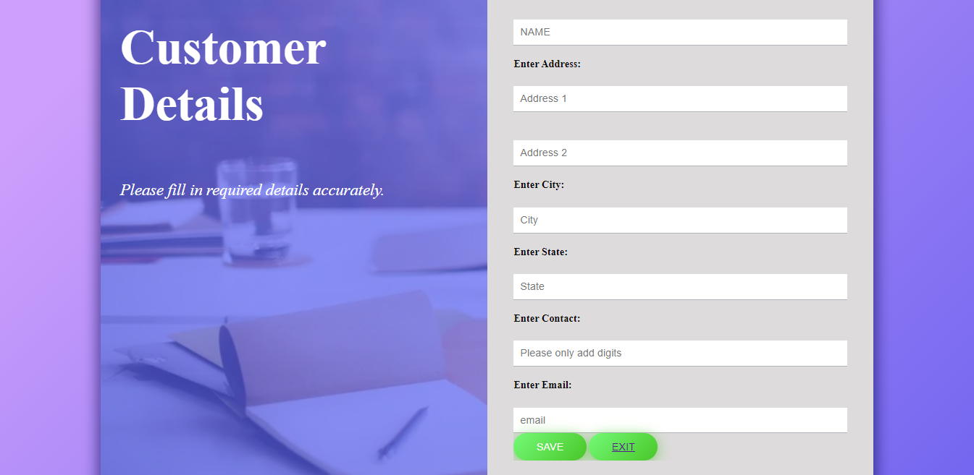

1. Only URL will be accepted where specified:

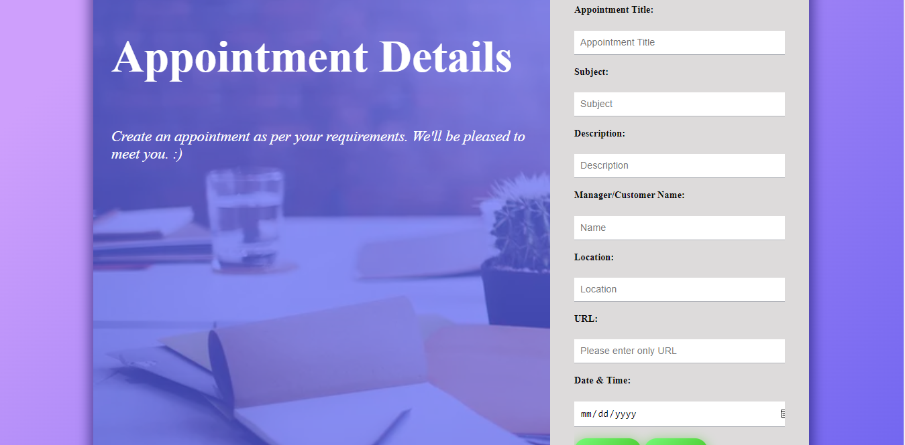

1. Date will be accepted only in specified format:

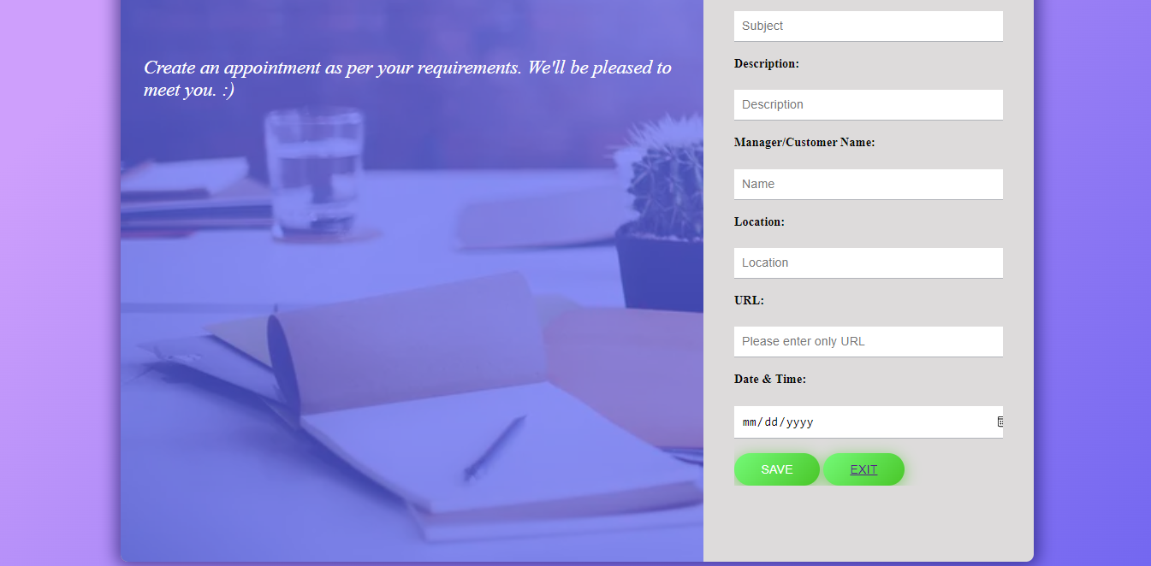

1. Confirmation message should be displayed after filling data successfully:

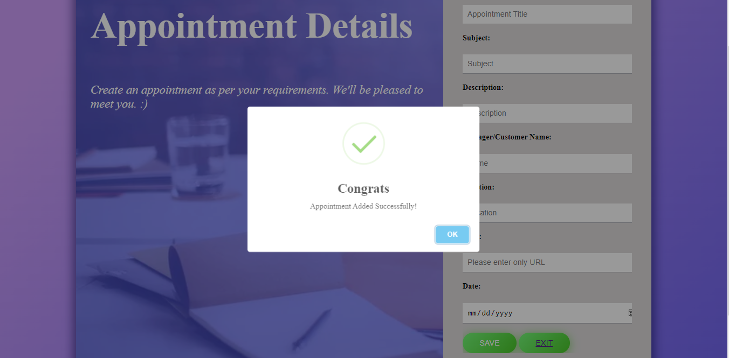

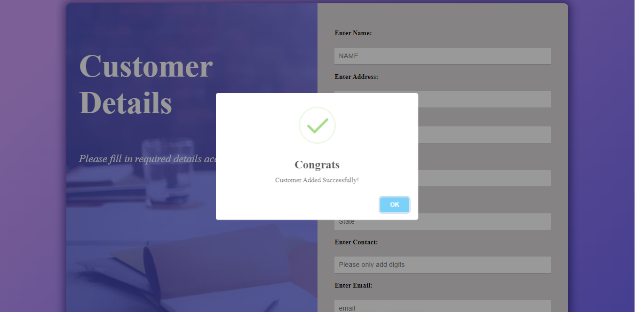

INPUT SCREENS

* Login Page:

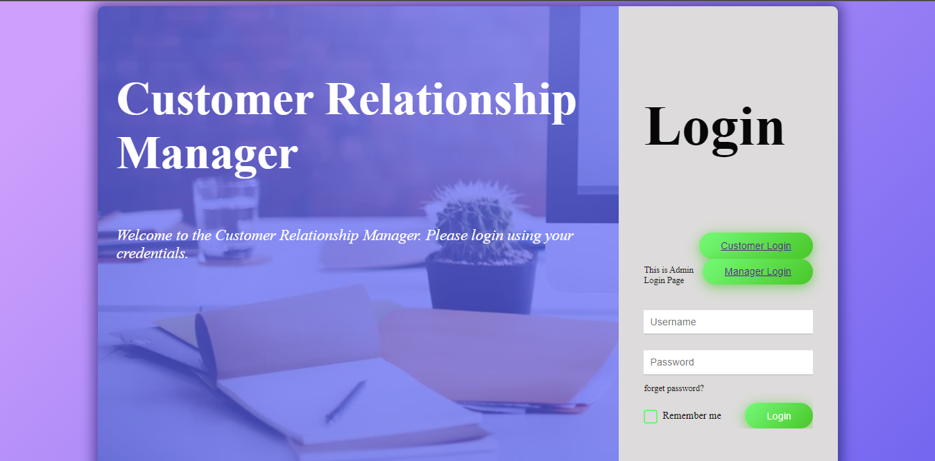

* Menu Page:

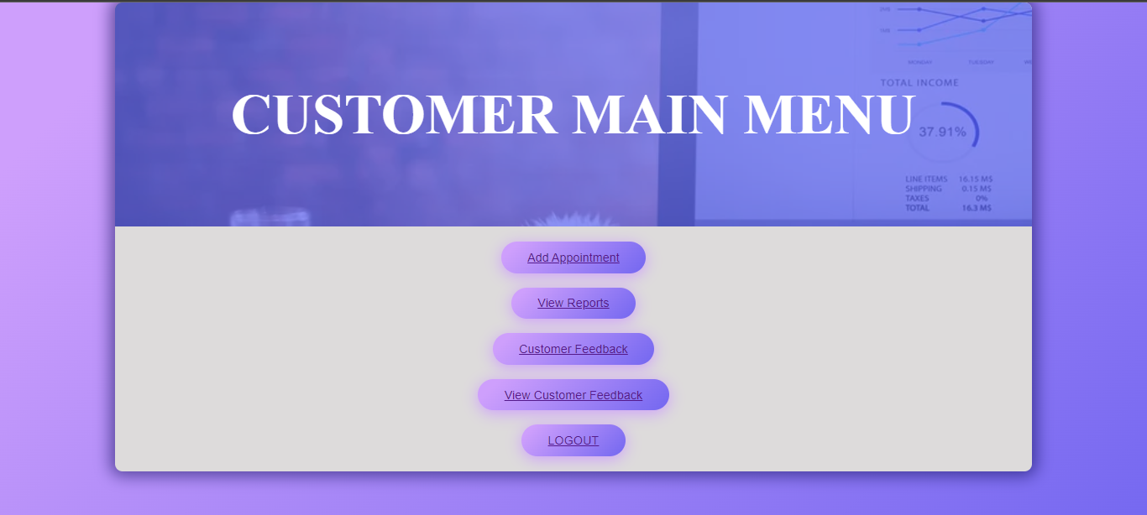

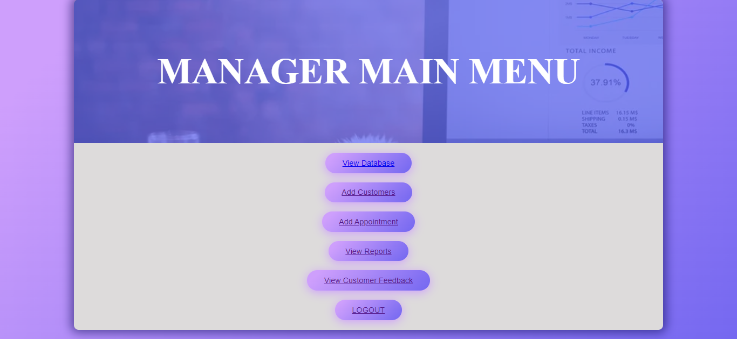

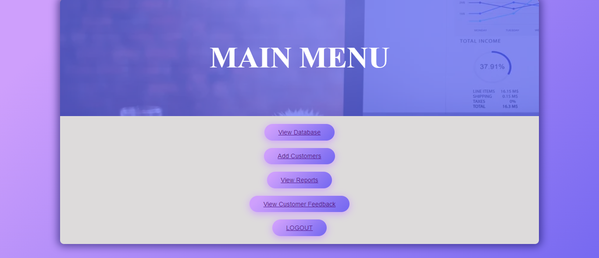

* Add Customer:

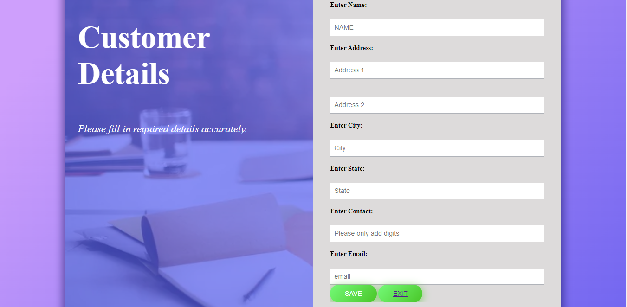

* Add Appointment:

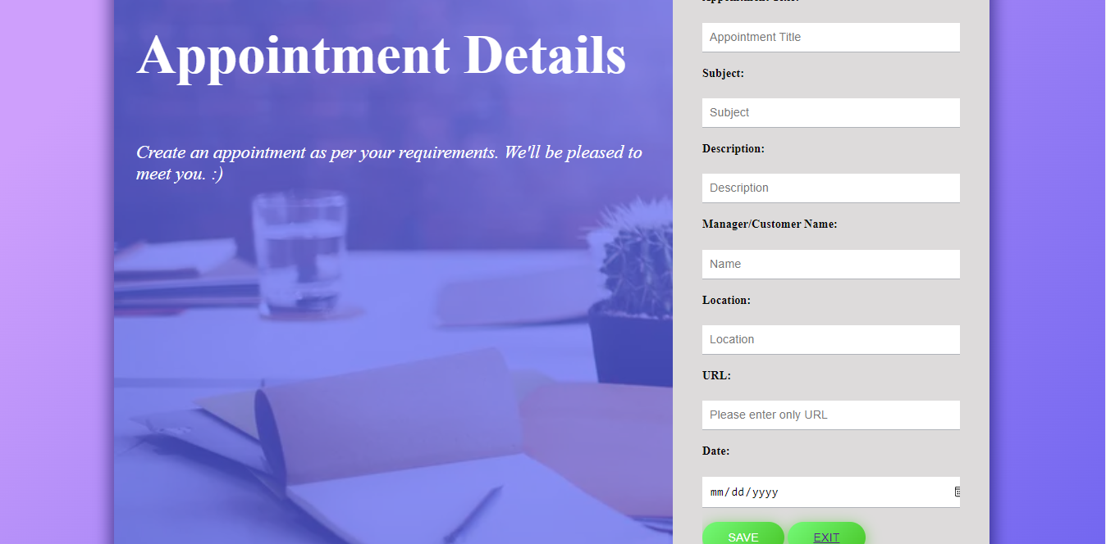

OUTPUT SCREENS

* Appointment Details sorted Month wise:

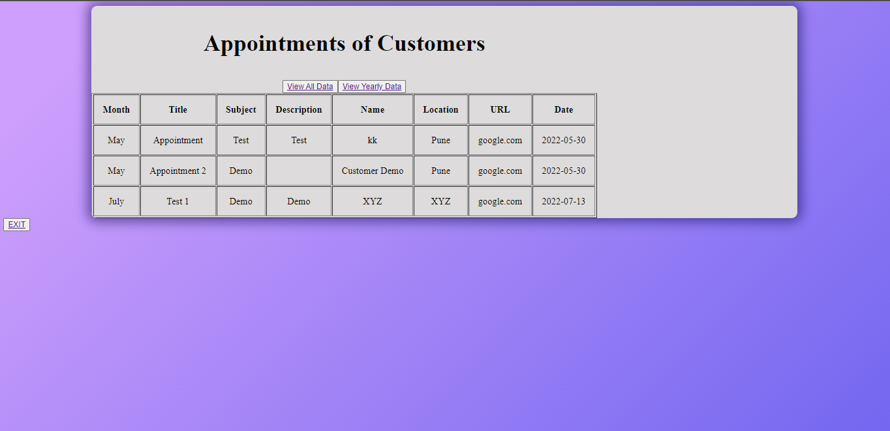

* Appointment details sorted Yearly:

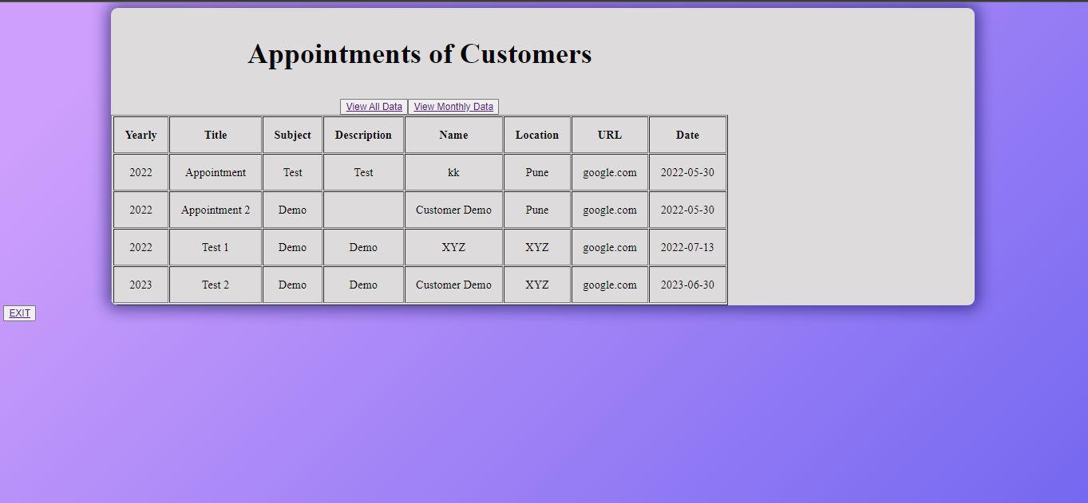

* Appointment Report Total Entries:

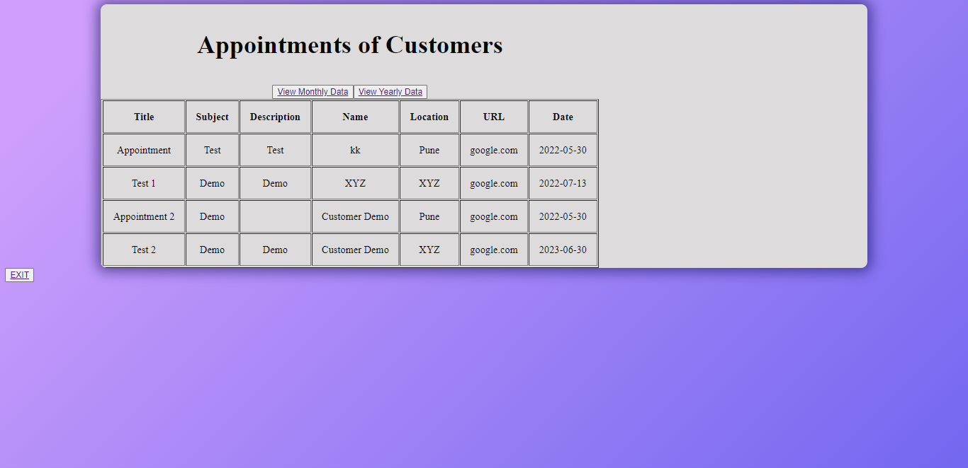

* Customer Feedback Total Entries:

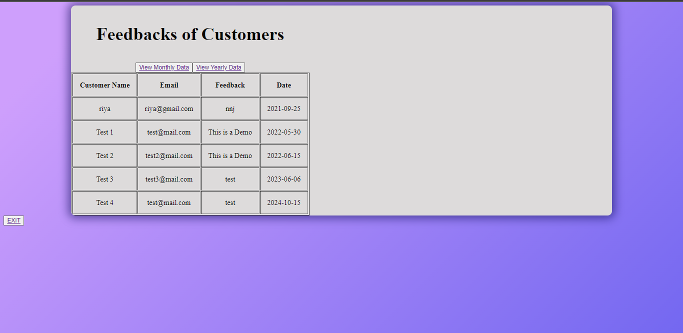

* Customer Feedback sorted Monthly:

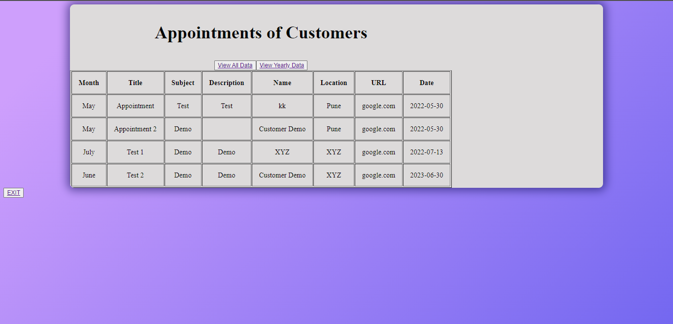

* Customer Feedback Yearly:

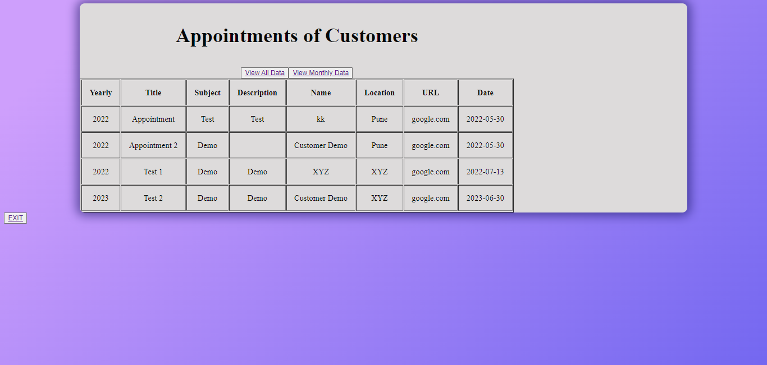

* Database Of Customer Details:

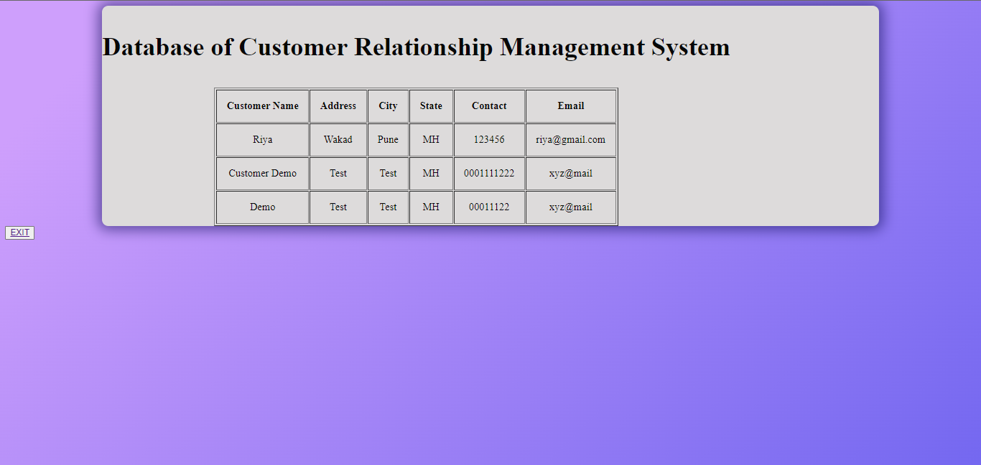

REPORT

Customer relationship management solutions provide customer-oriented services for planning, developing, maintaining and expanding customer relationship. CRM is the abbreviated form of customer relationship management and can be defined as a process or method used to know the customers’ needs and buying behaviors.

The sole aim of CRM is to develop strong and deep relationships with the customers, so as to benefits the business as well as the customers. According to the concept customer is the king and the needs and desires of the customers hold a vital place in the minds of the business and businessmen.

CRM should be considered as a process that brings together pieces of information related to sales, customers, marketing effectiveness, market trends and responsiveness.

CRM consists on an strategy of the organization, it is focused on the efforts of knowing the customers, detecting their needs, increasing the grade of satisfaction and their loyalty to the enterprise, also raising the profitability or the benefits of the costumer to the business. All this is made by means of the extracted information by the customers from the different ways of communication.

CONCLUSION & RECOMMENDATIONS

* This project will provide businesses with the best and the most hassle-free solution for managing customer information.
* The web application provides managers options to create, update, read, delete customer data/ profiles from and on the database.
* This helps the managers to keep track of their customers anytime and keep a record in an easy, hassle-free method.
* This system will have roles and access rights based on access rights chosen elements will be accessed or shown. There will be a special admin section to edit access rights. Spring security will be used to achieve this.
* It makes the access of customer data easier and makes it always available on their fingertips.
* The system will have a function to export data in the form of pdf, csv files.
* The system is easy to use and have same steps for the process each time it is used by the end user.
* This system can also be used to keep track of user preferences and can be used in future to conduct analysis and find useful information as data storing is simple and all the records can be found in one place.

FUTURE SCOPE

1. It can be made as a mobile app for platforms Android and IOS.

2. CRM, in future can be totally analytics driven. In other words, it would be used along with Data Analytics and the emerging trend of Big Data

3. Various features can be customized as per the user requirements.

4. User Interface can be improved, and dark mode can be introduced.

5. Format of data display and Output tables can be improved.

BIBLIOGRAPHY & REFERNCES

[www.google.com](http://www.google.com)

[www.geeksforgeeks.com](http://www.geeksforgeeks.com)

[www.w3schools.com](http://www.w3schools.com)

[www.oracle.com](http://www.oracle.com)

[www.stackoverflow.com](http://www.stackoverflow.com)

[www.javatpoint.com](http://www.javatpoint.com)

[www.tutorialspoint.com](http://www.tutorialspoint.com)